Student Enrollment & Course Management System
Project Development Phase
Phase Objective
This phase documents the practical implementation of the Student Enrollment and Course Management System on the Salesforce platform. It covers the creation and configuration of the application components, including objects, fields, relationships, validation rules, approval processes, automation, reports, dashboards, and security settings.
Phase Deliverables
The development work is organized as milestones and activities so that each configured component can be created, connected, reviewed, and prepared for testing.

6. PROJECT DEVELOPMENT

Project Flow:
Milestone 1: Salesforce Developer Account Creation
Milestone 2: Custom Object Creation (Student, Course, Enrollment, Instructor)
Milestone 3: Tabs Creation
Milestone 4: Lightning App Creation
Milestone 5: Fields Creation
Milestone 6: Create Relationships
Milestone 7: Page Layout Customization
Milestone 8: Validation Rules
Milestone 9: Flows
Milestone 10: Approval Process
Milestone 11: Reports
Milestone 12: Dashboards
Milestone 13: Security Setup
Milestone 14: Conclusion

WHAT YOU’LL LEARN
Through the development of the Student Enrollment and Course Management System, the project provides practical knowledge of Salesforce application development and management. The following skills and concepts can be learned through the project:

1. Salesforce Platform Basics
Understand the Salesforce environment, navigation, and basic platform features.

3. Custom Object Creation
Learn how to create and configure custom objects for managing application data.

4. Field Management
Understand different field types and how to create fields according to system requirements.

5. Tabs and Lightning App Development
Learn how to organize custom objects using tabs and build a dedicated Lightning application.

6. Object Relationships
Understand how related records can be connected using Salesforce relationship fields.

7. Page Layout Customization
Learn how to arrange fields and record information for a clear and user-friendly interface.

8. Validation Rules
Understand how validation rules can be used to maintain accurate and consistent data.

9. Salesforce Flow Automation
Learn how to automate repetitive tasks and system processes using Flows.

10. Approval Process
Understand how approval workflows can be configured for reviewing and processing enrollment requests.

11. Reports and Dashboards
Learn how to create reports and dashboards to organize and visualize important system information.

12. Security and Access Control
Understand how Salesforce security settings can control access to application data and features.

13. Application Development Workflow
Gain practical experience in planning, configuring, testing, and completing a Salesforce-based application.

Milestone 1-Salesforce :

Introduction:
Salesforce is a cloud-based Customer Relationship Management (CRM) platform that provides tools for managing business data, processes, communication, and customer-related activities. It allows organizations to store information in a centralized environment and access it through a web-based interface.
For the Student Enrollment and Course Management System, Salesforce can be used to organize information about students, courses, instructors, and enrollment records. Custom objects can represent these entities, while relationships connect related information. Automation and approval features can support enrollment- related processes, and reports and dashboards can provide useful views of the stored data.
The platform also provides access control mechanisms that help manage which users can view or modify particular information. Since Salesforce operates through the cloud, the application can be accessed through a supported web browser without requiring the complete system to be installed locally.

What Is Salesforce?
Salesforce provides configurable features such as objects, fields, relationships, automation, reports, dashboards, and security controls. These features allow applications to be developed according to specific organizational requirements without depending entirely on traditional software development methods.Overall, Salesforce provides a flexible platform for building and managing a structured enrollment application by combining data management, automation, reporting, and security features within a single environment.

Activity 1: Creating Developer Account:
A Salesforce Developer Account provides a separate environment for learning, testing, and developing Salesforce applications. The account creation process establishes the workspace where the project components can be configured.
Creating a developer org in Salesforce.
Go to the Salesforce Developer registration page.
On the sign-up form, provide the required personal and organization details such as:
- First Name and Last Name
- Email Address
- Role
- Company or College Name
- Country
- Postal Code
- Unique Username
The username should follow the required Salesforce format and must be unique. After entering the details, submit the registration form. Salesforce will send an account verification message to the registered email address.
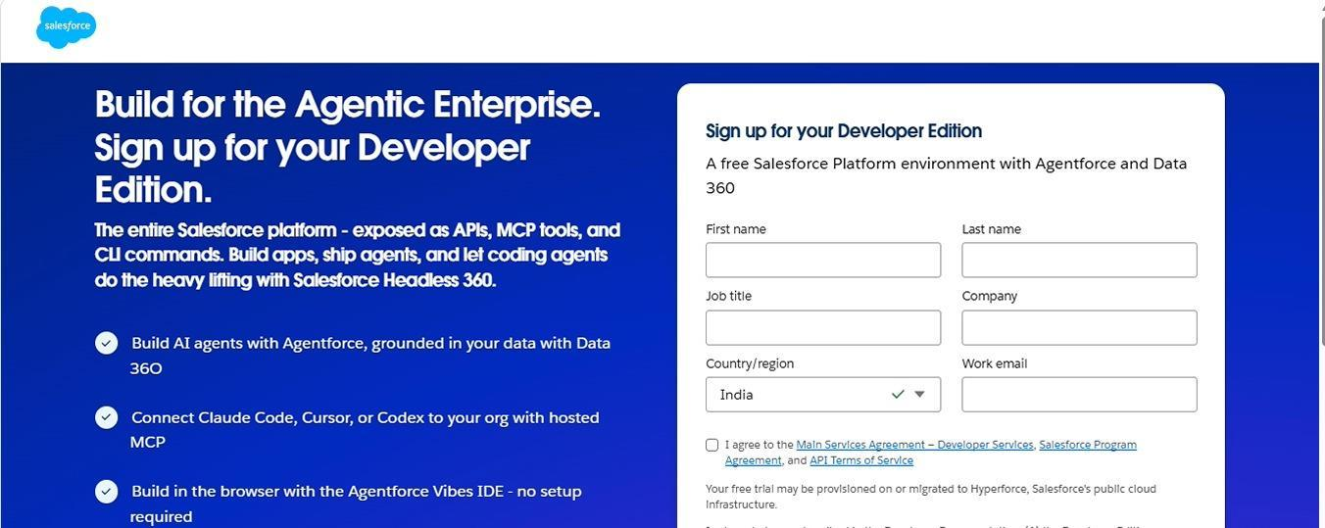
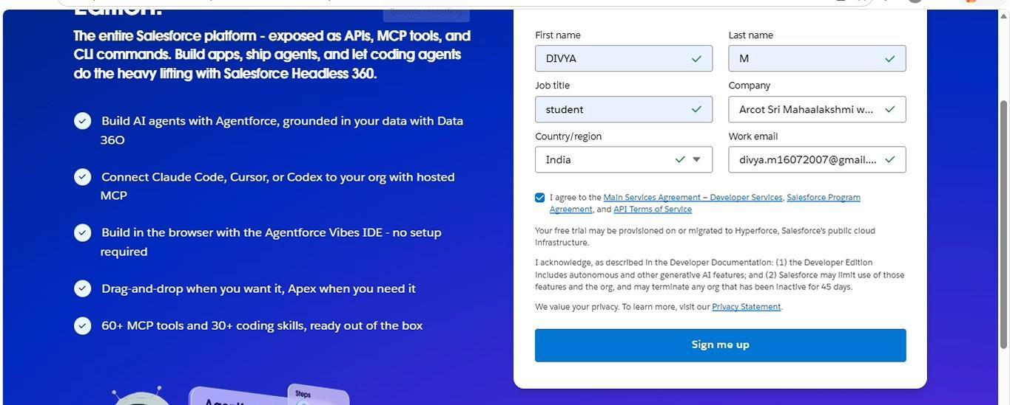
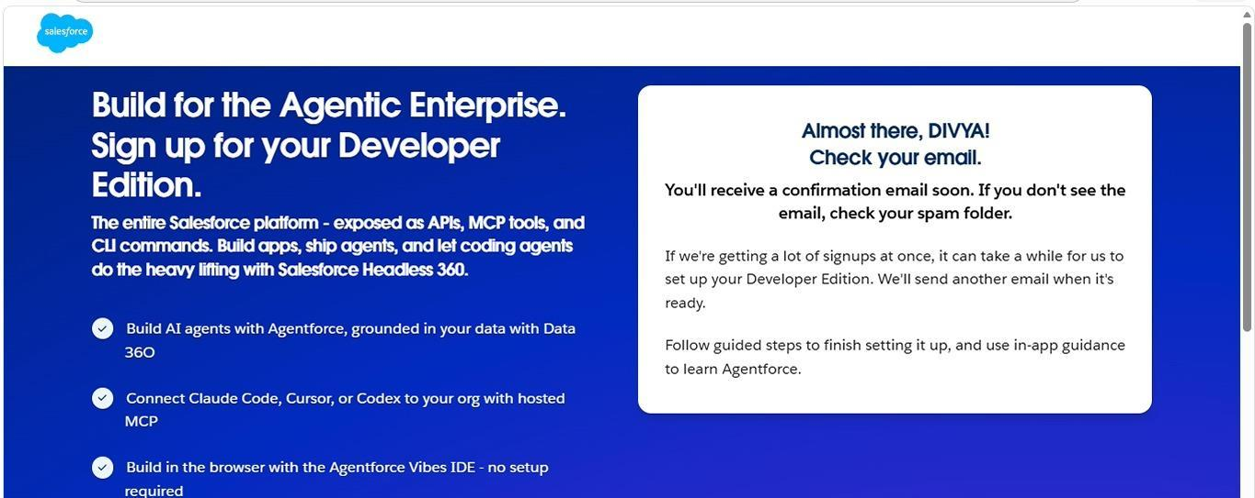
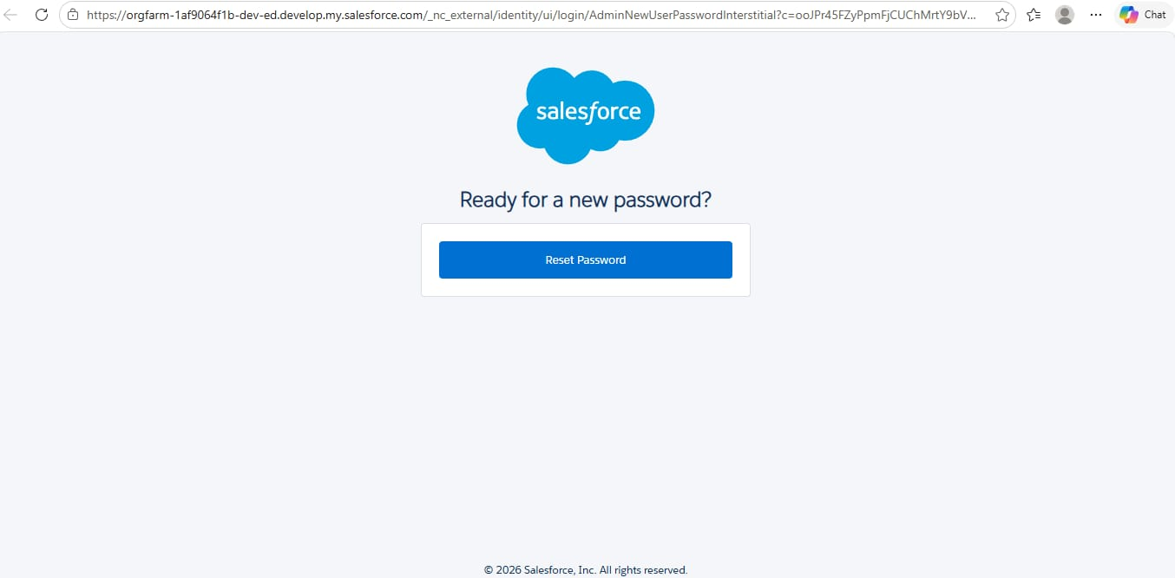

Activity 2: Account Activation
After registering the Developer Account, the account must be activated before accessing the Salesforce environment.
1. Open the email account used during registration.
2. Locate the Salesforce verification email.
3. Select the account verification option provided in the message.
4. Create a secure password when prompted.
5. Complete the security-related setup information.
6. Save the account settings.
7. Sign in to Salesforce using the newly created credentials.
8. The Salesforce setup environment will then be available for project development.
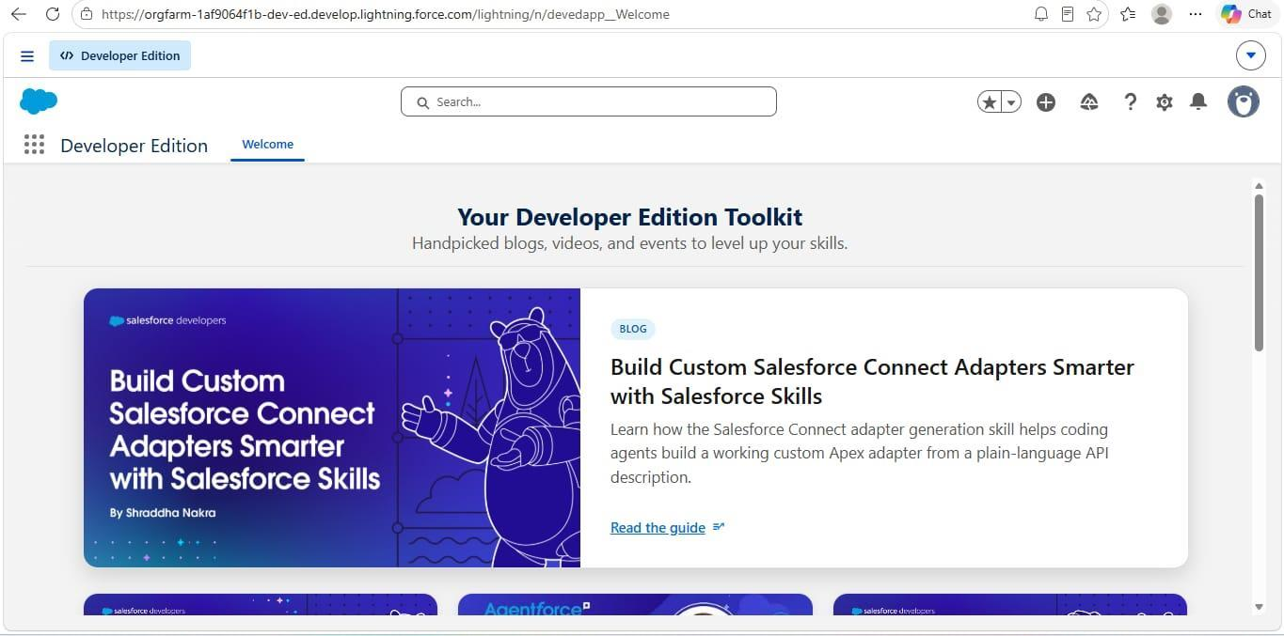
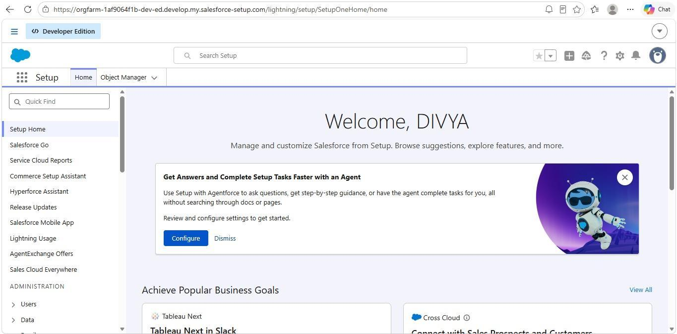
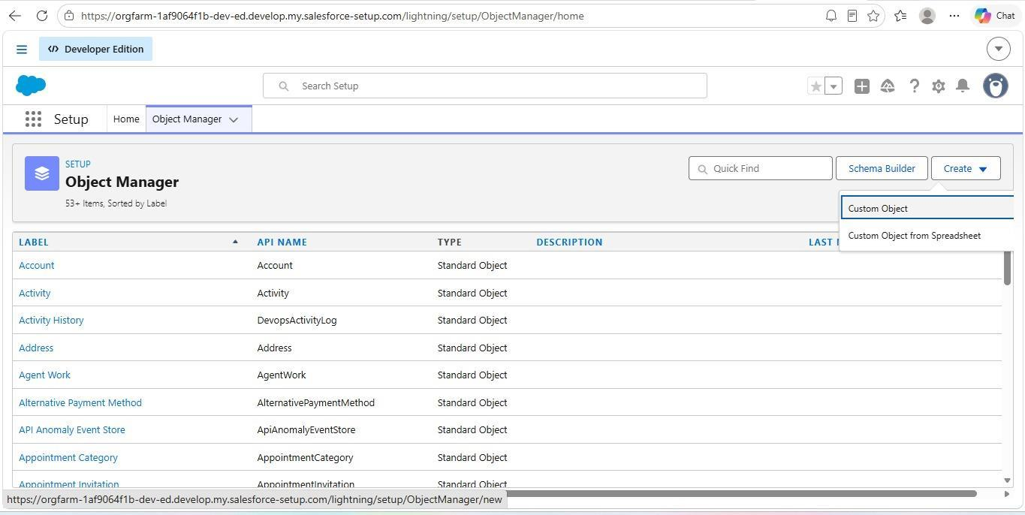

Milestone 2 – Objects:
Objects provide the basic structure for storing information in Salesforce. For this project, custom objects are created to represent the main entities involved in the enrollment process.

Activity 1: Creating Student Object:
The Student object is designed to maintain information related to individual students. It provides a structured location for storing details required during registration and enrollment.
To create the Student object:
1. Open Setup.
2. Navigate to Object Manager.
3. Select the option to create a Custom Object.
4. Enter Student as the object label.
5. Enter Students as the plural label.
6. Select an appropriate record name.
7. Configure the required object options.
8. Enable reporting and other required features.
9. Enable search if required.
10. Save the custom object.
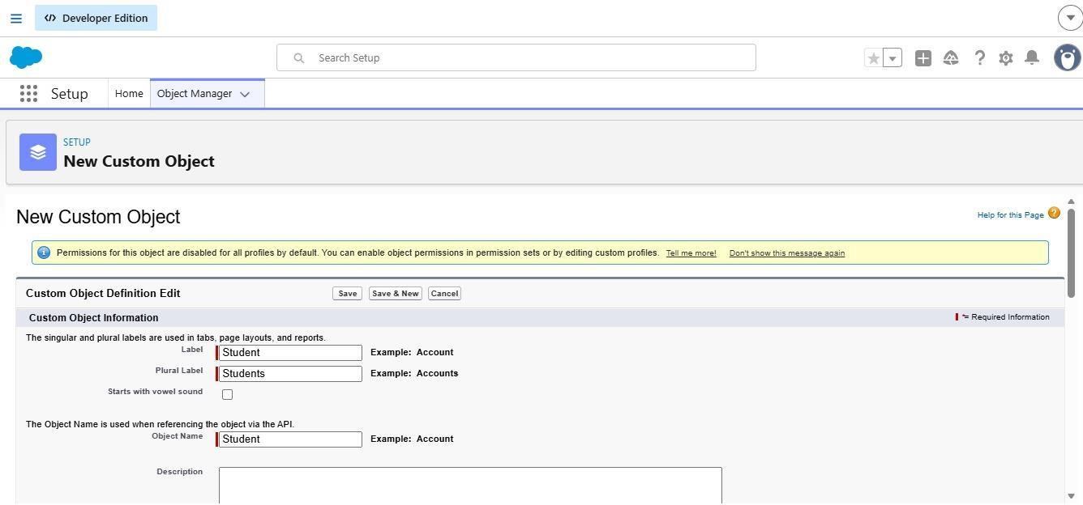
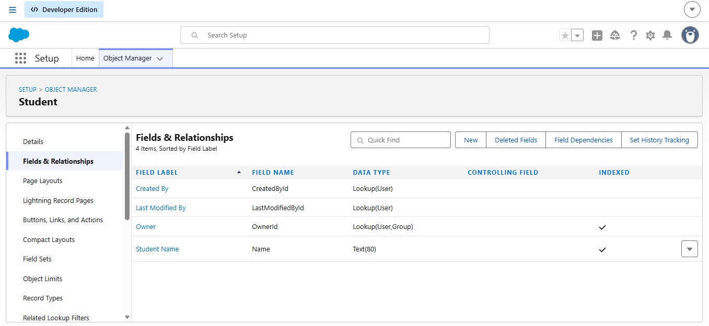
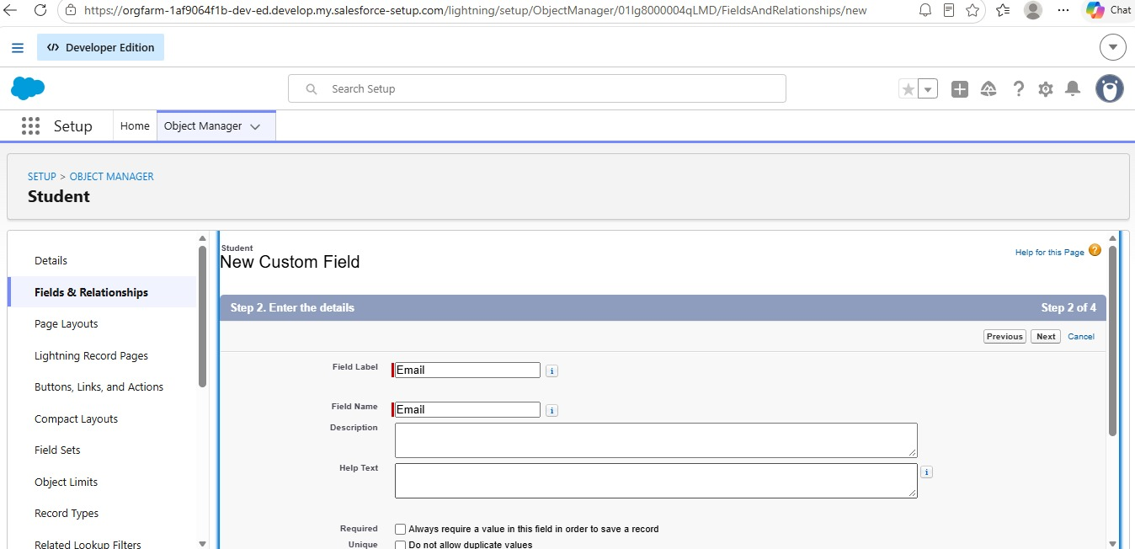
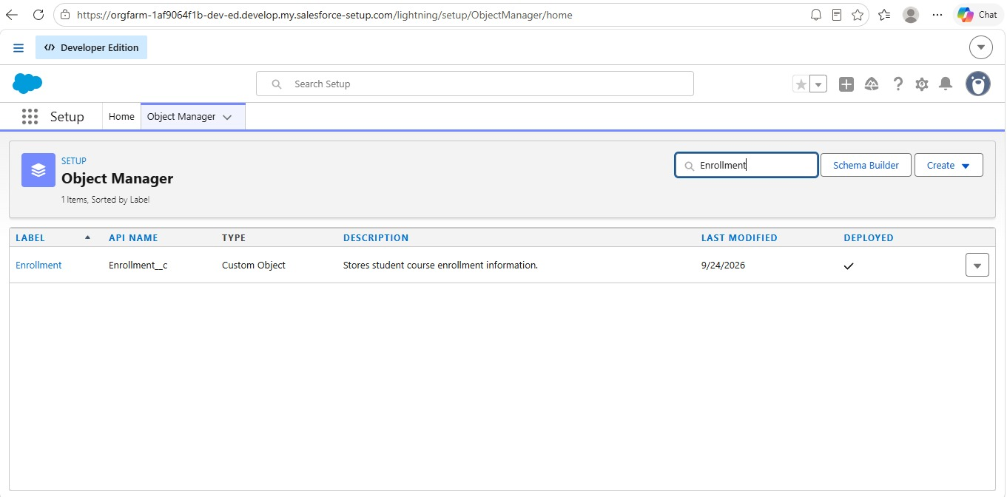
The same object creation approach can be followed for the Courses, Instructors, and Enrollments objects.

Milestone 3 - Fields:
Fields are used to store individual pieces of information within each Salesforce object. The fields required for the project are designed according to the information that needs to be collected and managed.

Table 1: Student Object Fields:
Field Label | Data Type
Student Name | Text (Standard)
Email | Email
Phone | Phone
Date of Birth | Date
Student Status | Picklist
Address | Text Area

Table 2: Course Object Fields:
Field Label | Data Type
Course Name | Text (Standard)
Category | Picklist
Duration | Number/Text
Course Fee | Currency
Description | Text Area

Table 3: Instructor Object Fields:

Instructor Object Fields

1. Instructor Name – Text (Standard)
The Instructor Name field is used to store the full name of the instructor. It is maintained as a text field so that the instructor's name can be entered and displayed clearly within the system.

2. Instructor Code – Text
The Instructor Code field is used to store a unique identification code for each instructor. This code helps authorized users identify and distinguish individual instructors from one another.

3. Expertise – Picklist
The Expertise field is used to record the instructor's area of specialization. A picklist provides predefined options, allowing users to select an appropriate expertise category consistently.

4. Phone – Phone
The Phone field stores the instructor's contact number. It allows authorized users to access the required contact information when communication with the instructor is necessary.

5. Email – Email
The Email field stores the instructor's email address. It can be used for official communication, notifications, and other instructor-related activities within the system.

Milestone 4 – Create Relationships:
Relationships connect records from different objects so that related information can be accessed together. In this project, the Enrollment object is connected with Student, Course, and Instructor objects.

1. Activity 1: Create Lookup from Enrollment to Student:
This relationship connects an enrollment record with the student who submitted or belongs to that enrollment.
1. Open Setup and select Object Manager.
2. Search for and open the Enrollment object.
3. Select Fields & Relationships.
4. Click New.
5. Select Lookup Relationship.
6. Select Student as the related object.
7. Enter Student as the field label.
8. Configure the field visibility and page layout settings.
9. Save the relationship field.
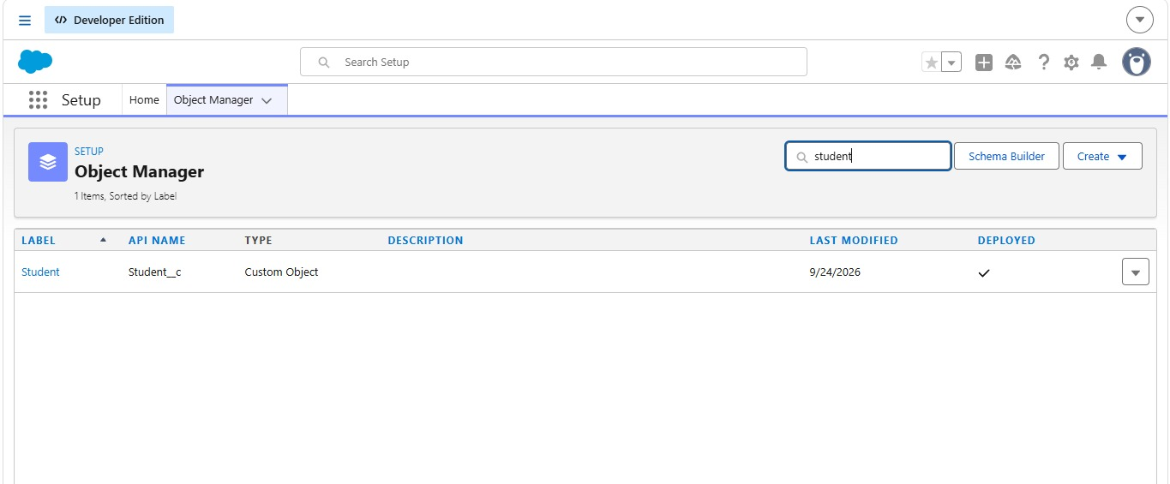

Activity 2: Create Lookup from Enrollment to Course

Purpose:
The Course lookup connects every enrollment record with the course selected by the student.

Steps:
1. Open the Enrollment object from Object Manager.
2. Go to Fields & Relationships.
3. Select New.
4. Choose Lookup Relationship.
5. Select Course as the related object.
6. Enter Course as the field label.
7. Configure field-level access and page layout settings.
8. Save the field.

Activity 3: Create Lookup from Enrollment to Instructor:

Purpose:
This relationship identifies the instructor associated with an enrollment record.

Steps:
1. Open Setup → Object Manager → Enrollment.
2. Navigate to Fields & Relationships.
3. Click New.
4. Select Lookup Relationship.
5. Choose Instructor as the related object.
6. Enter Instructor as the field label.
7. Configure the required visibility settings.
8. Add the field to the appropriate layout.
9. Save the relationship.

Milestone 5 – Validation Rules:
Validation Rules are used to check information before a record is saved. They help maintain consistent data and prevent records from being stored when specific conditions are not satisfied.

Activity 1: Student Email Domain Validation

Purpose:
The purpose of this validation is to ensure that the email entered for a student follows the expected institutional email format.

Steps:
1. Open Setup → Object Manager → Student.
2. Select Validation Rules.
3. Click New.
4. Enter a suitable rule name such as Student_Email_Domain_Validation.
5. Create a formula that checks the student's email domain.
6. Enter an appropriate error message.
7. Select the email field as the error location.
8. Save the validation rule.
The rule prevents an invalid email format from being accepted during student record creation or modification.

Activity 2: Fees Must Be Paid Before Approval

Purpose:
This validation ensures that an enrollment cannot be marked as approved when the required fee payment has not been recorded.

Steps:
1. Open Setup → Object Manager → Enrollment.
2. Navigate to Validation Rules.
3. Click New.
4. Provide a meaningful rule name.
5. Configure a condition that checks both enrollment status and fee payment.
6. Add an error message explaining that payment must be completed.
7. Choose the appropriate error location.
8. Save the rule.

Milestone 6 – Approval Process

Activity 1: Create Approval Process for Enrollment Requests

Purpose:
The approval process provides a controlled method for reviewing enrollment requests before they are finalized. It allows an authorized person to examine the request and either approve or reject it.

Steps:
1. Open the Salesforce setup area for approval processes.
2. Select the Enrollment object.
3. Create a new approval process using the standard setup option.
4. Enter a suitable process name such as Approval_Enrollment_Request.
5. Define the entry condition for enrollment requests that require approval.
6. Configure the approval step.
7. Assign the appropriate Training Manager or authorized approver.
8. Configure the final approval action to update the enrollment status.
9. Configure the final rejection action to update the status as rejected.
10. Add an appropriate notification action if required.
11. Review the complete process.
12. Activate the approval process.
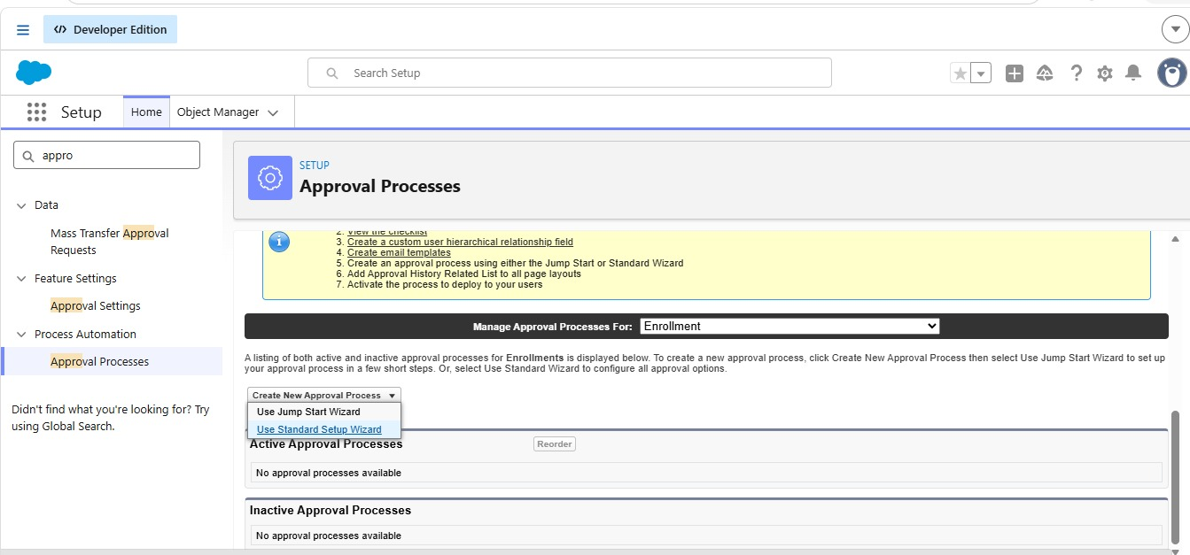
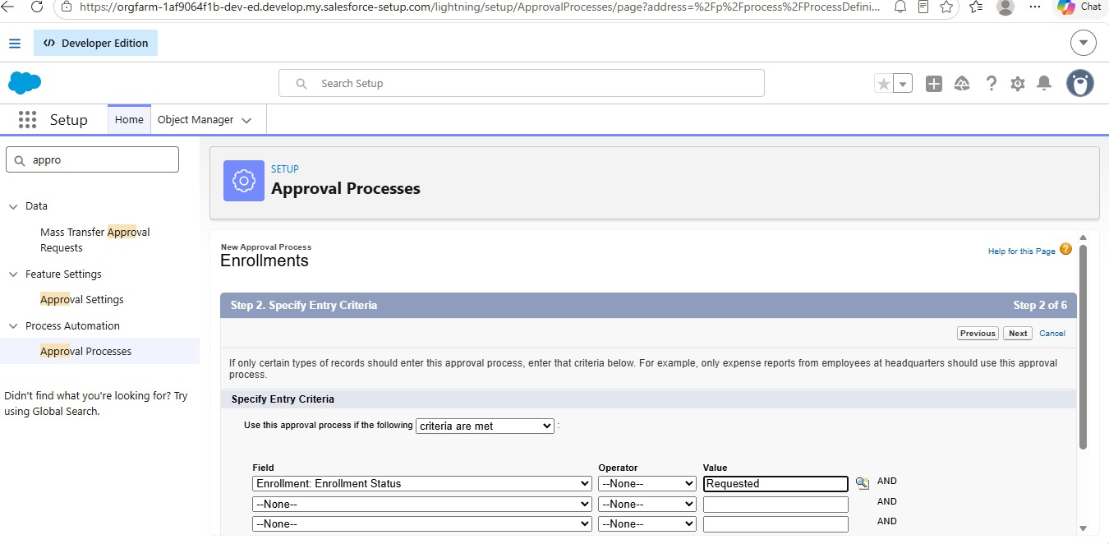
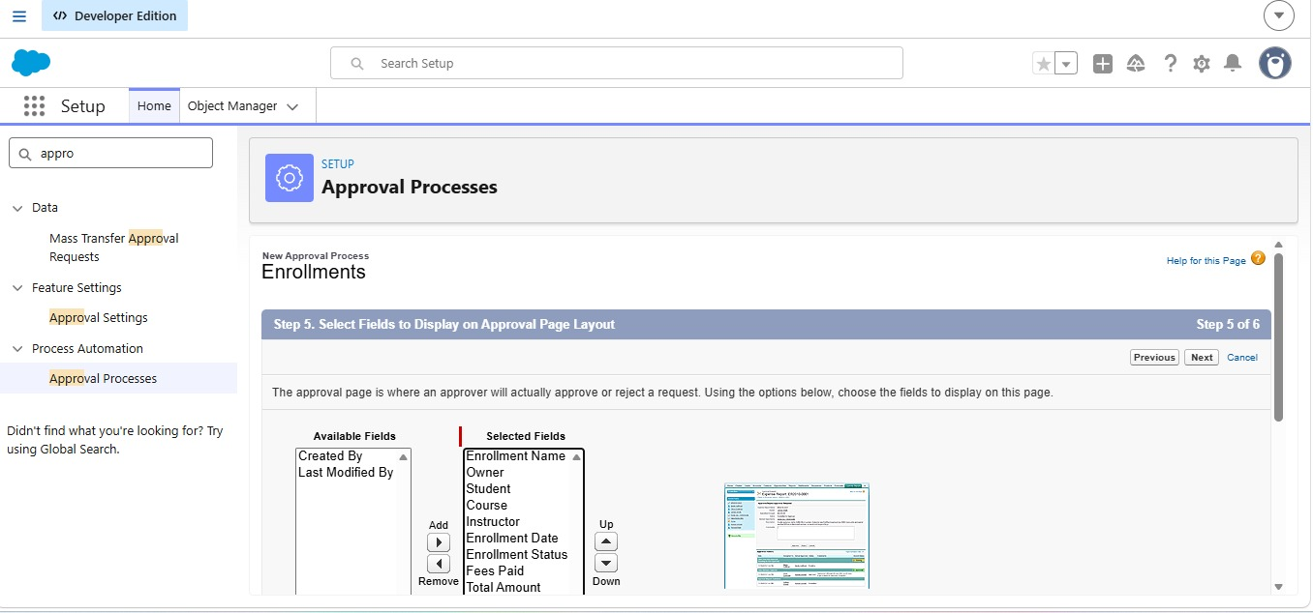

Milestone 7- Tabs
Tabs provide direct navigation to objects and application features. They make it easier for users to access the records required for daily activities.

Activity 1: Creating a Tab for the Student Object:
1. Open Setup.
2. Search for Tabs.
3. Open the Custom Object Tabs section.
4. Select New.
5. Choose the Student object.
6. Select an appropriate tab style.
7. Configure visibility for the required profiles.
8. Save the tab.
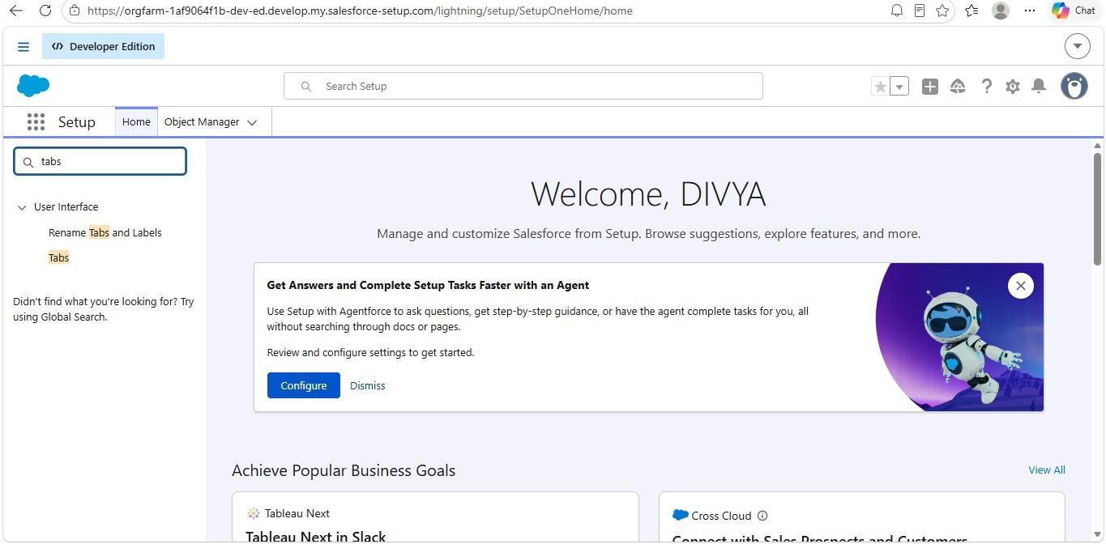
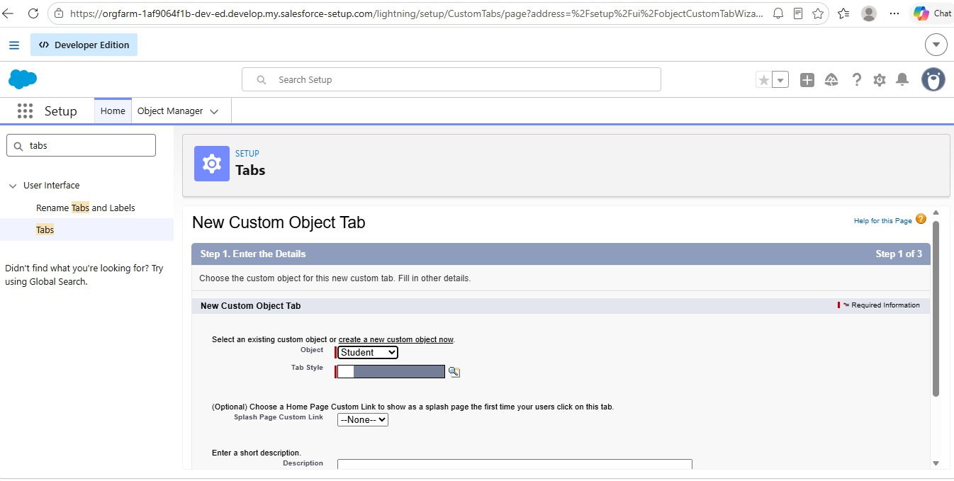

Activity 2: Creating Remaining Tabs
The same process is used to create tabs for the remaining project objects.
The required tabs are:
- Courses
- Instructors
- Enrollment
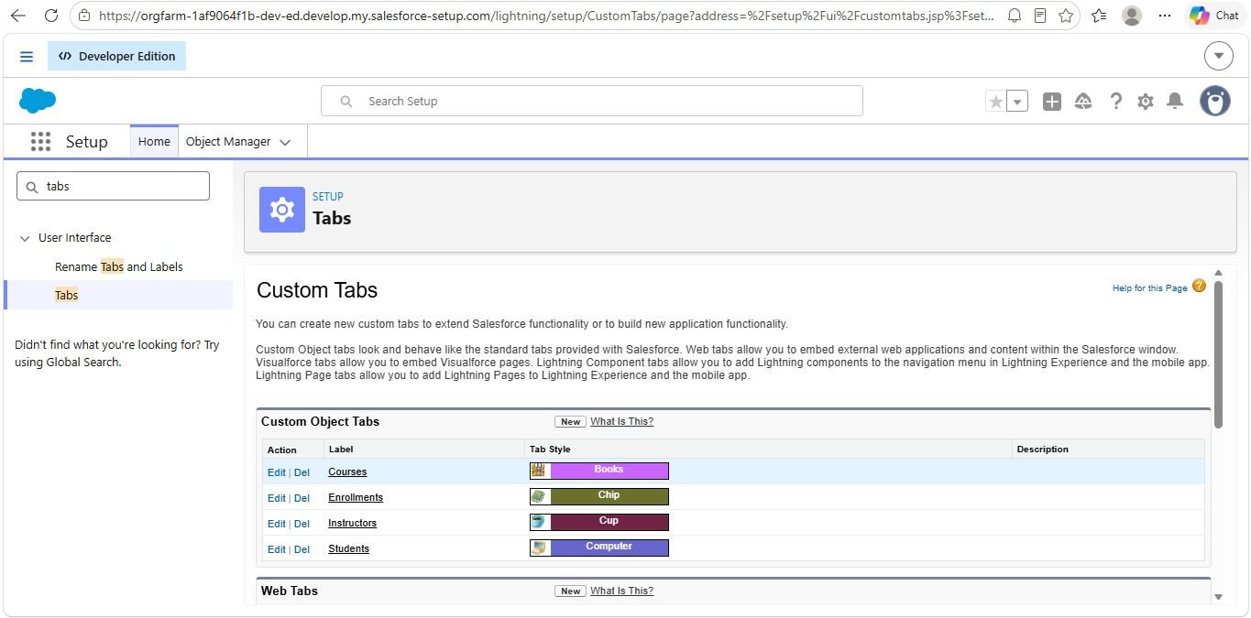
These tabs provide users with direct access to the corresponding records from the Salesforce application.

Milestone 8 - The Lightning App

Activity 1: Creating the Lightning Application for the Project
The Lightning App brings the different components of the project together in a single Salesforce workspace. It provides users with a structured navigation system for accessing project records and features.

Steps:
1. Open Setup.
2. Search for App Manager.
3. Select New Lightning App.
4. Enter the application name as Student Enrollment & Course Management.
5. Review the automatically generated developer name.
6. Add a suitable description if required.
7. Configure application branding if needed.
8. Select an appropriate navigation style.
9. Assign the application to the required profiles.
10. Add the project objects and Salesforce features to the navigation menu.
- Include:
- Student
- Course
- Instructor
- Enrollment
- Reports
- Dashboards
- Home
- Tasks
11. Review the configuration.
12. Select Save & Finish.
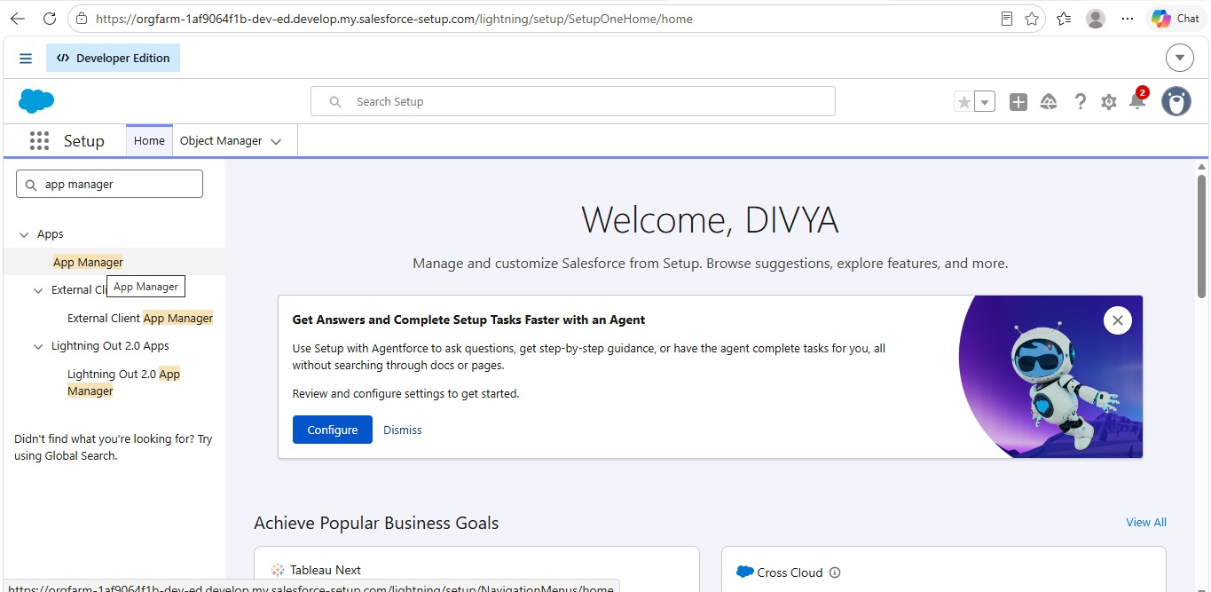
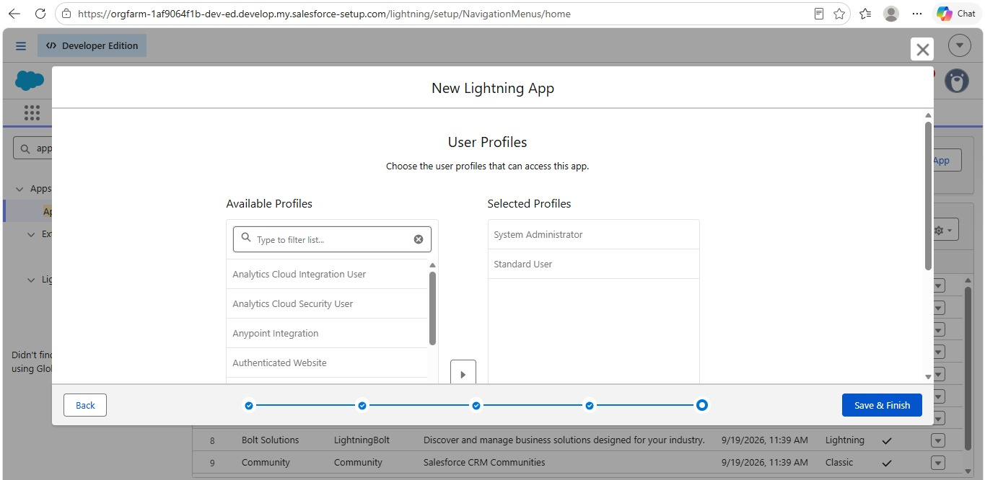
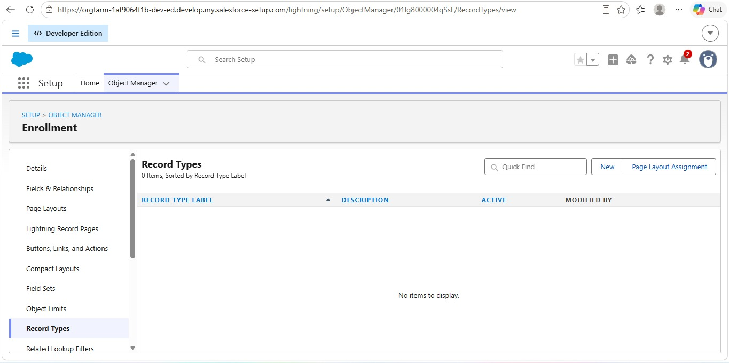

Milestone 9 – Page Layouts and Record:
Page layouts control the arrangement and visibility of fields and related information on Salesforce record pages. Record Types can be used to provide different processes and layouts for different enrollment categories.
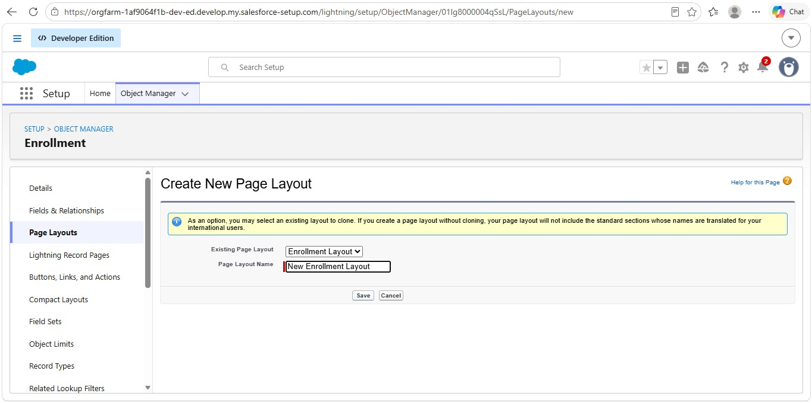
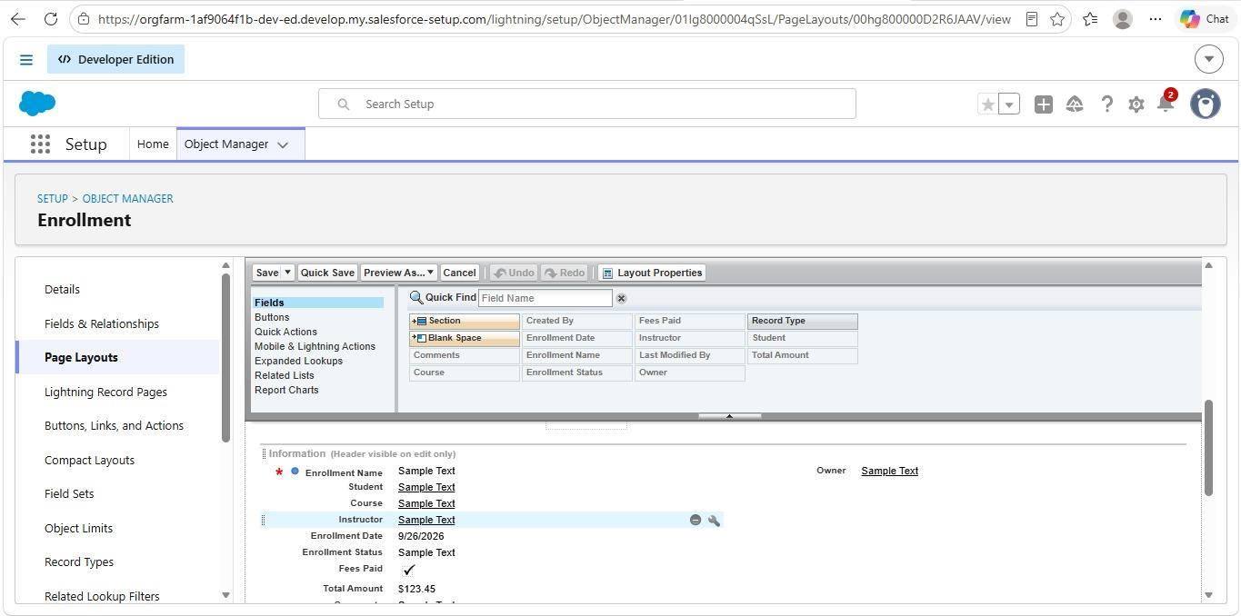
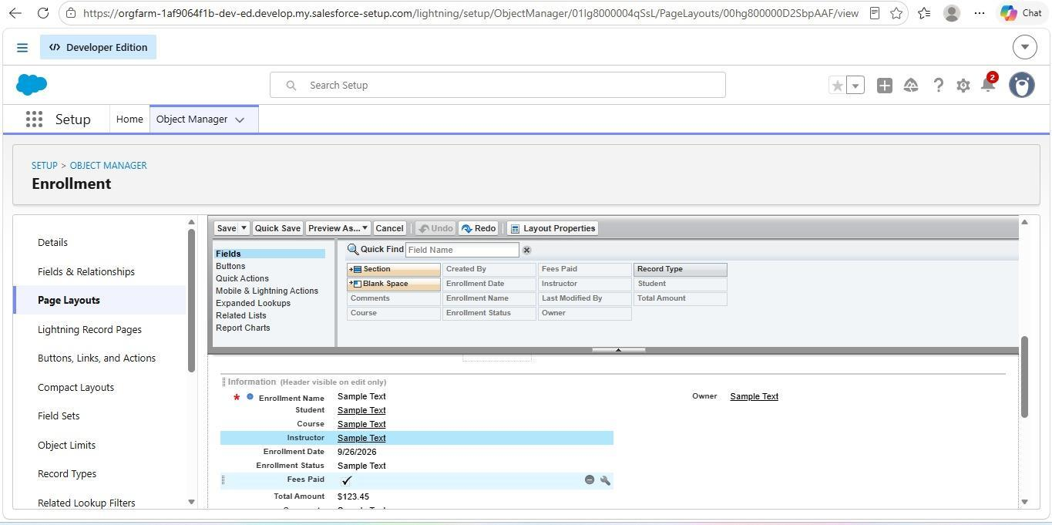

Activity 1: Create Record Types for Enrollment:

Purpose:
Record Types are created to distinguish between New Enrollment and Re- Enrollment activities.

Steps:
1. Open Setup → Object Manager → Enrollment.
2. Select Record Types.
3. Click New.
4. Use the existing master record type as the starting point.
5. Enter New Enrollment as the first record type label.
6. Enable it for the required profiles.
7. Assign an appropriate page layout.
8. Save the record type.
9. Create another record type named Re-Enrollment.
10. Enable it for the required profiles.
11. Assign the relevant layout.
12. Save the configuration.
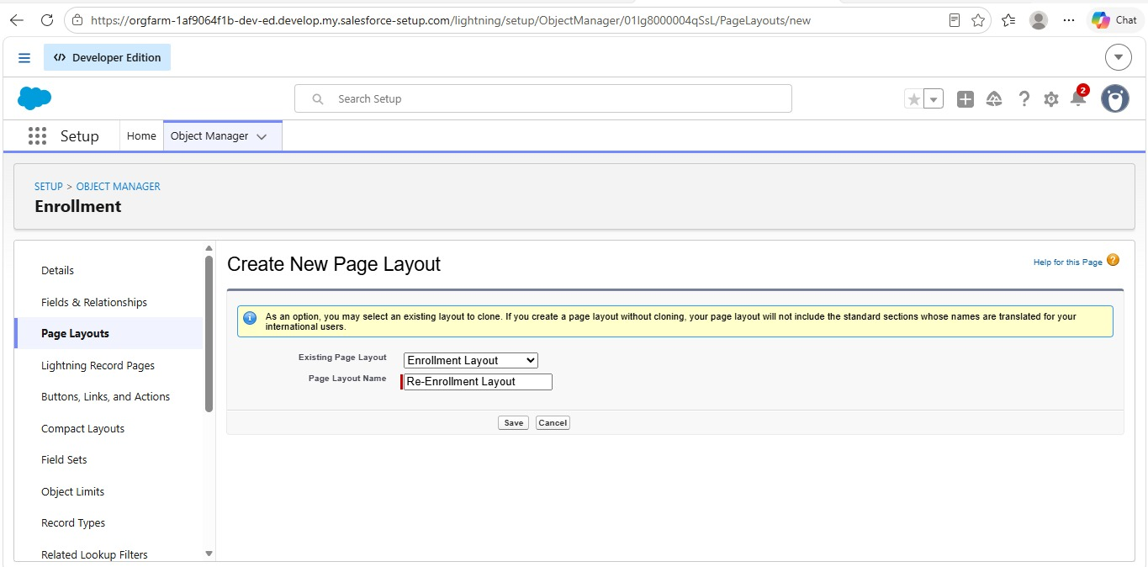

Activity 2: Separate Page Layouts for Each Enrollment Record

Purpose:
Separate layouts allow the system to display fields according to the type of enrollment being processed.

Steps:
1. Open the Enrollment object.
2. Navigate to Page Layouts.
3. Create a new layout for New Enrollment.
4. Clone an existing layout if appropriate.
5. Include fields needed for first-time enrollment.
6. Save the layout.
7. Create another layout for Re-Enrollment.
8. Add fields relevant to previous enrollment information and re-enrollment details.
9. Save the layout.
10. Open Page Layout Assignment.
11. Assign the New Enrollment layout to the corresponding record type.
12. Assign the Re-Enrollment layout to its corresponding record type.
13. Save the assignments.

Activity 3: Add Enrollment Related Lists to Parent Objects:

Purpose:
Related lists allow users to view enrollment records directly from the corresponding Student, Course, and Instructor records.

a) Student → Enrollment Related List
1. Open the Student object.
2. Navigate to Page Layouts.
3. Open the required layout.
4. Select Related Lists from the component palette.
5. Add the Enrollments related list.
6. Arrange the required columns.
7. Save the layout.

b) Course → Enrollment Related List
1. Open the Course object.
2. Select the appropriate page layout.
3. Add the Enrollments related list.
4. Configure the displayed columns.
5. Save the layout.

c) Instructor → Enrollment Related List
1. Open the Instructor object.
2. Open its page layout.
3. Add the Enrollments related list.
4. Configure the related-list information.
5. Save the layout.

Milestone 10 – Automation with Flow
Flows are used to automate activities that would otherwise require repeated manual actions. They help improve consistency and reduce unnecessary administrative work.

Activity 1: Auto-Populate Enrollment Date (Record-Triggered Flow)

Purpose:
The flow automatically records the current date when a new enrollment record is created.

Steps:
1. Open Setup → Flows.
2. Create a new Record-Triggered Flow.
3. Select the Enrollment object.
4. Configure the flow to run when a record is created.
5. Add an Update Records element.
6. Select the record that triggered the flow.
7. Set the Enrollment Date field to the current flow date.
8. Save the flow as SetEnrollmentDate.
9. Activate the flow.
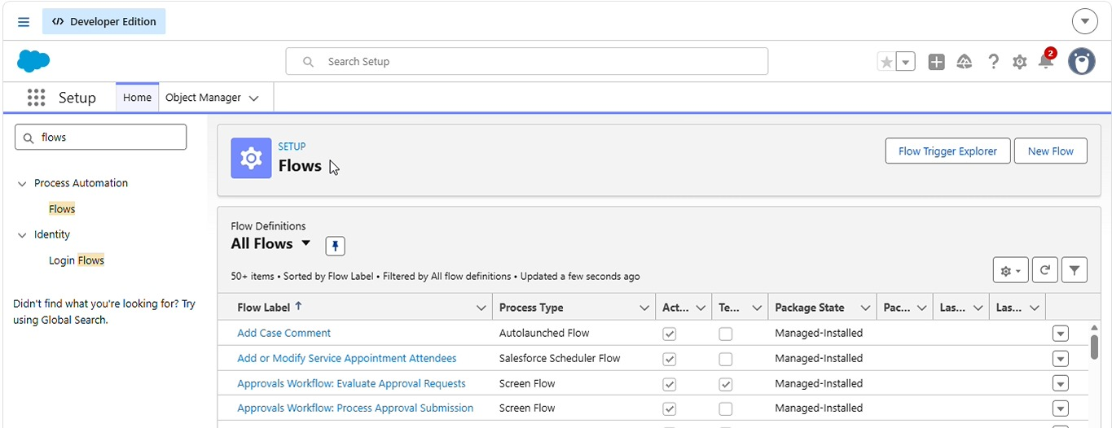
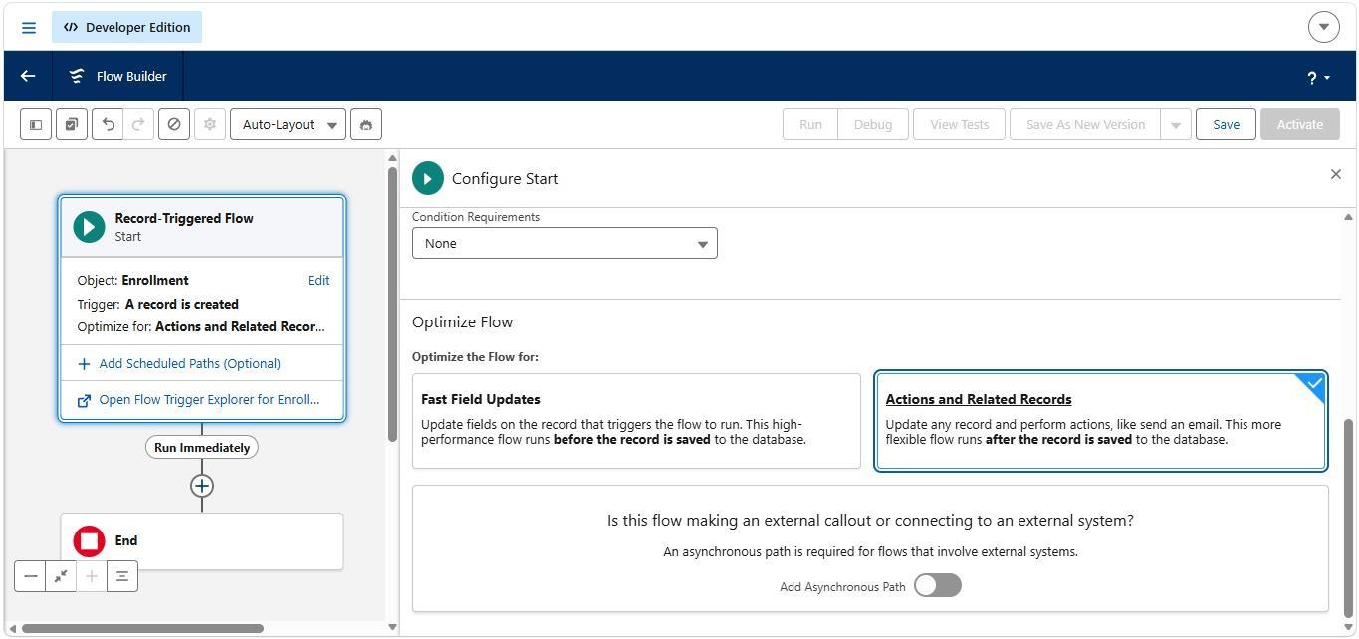

Activity 2: Send Email When Enrollment Approved

Purpose:
This automation communicates an approval decision to the relevant student and can update the student's status after successful enrollment approval.

Steps:
1. Prepare the required email template.
2. Create the corresponding email alert.
3. Create a record-triggered flow for the Enrollment object.
4. Configure the flow to run when the enrollment is updated.
5. Check whether the enrollment status becomes Approved.
6. Retrieve the related student information.
7. Send the appropriate email notification.
8. Perform the required student status update.
9. Save the flow with a suitable name.
10. Activate the automation.

Activity 3: Auto-Assign Instructor Based on Course Category

Purpose:
This automation assigns an instructor according to the category of the selected course.

Rules:
- Technical → Instructor A
- Language → Instructor B
- Non-Technical → Instructor C

Steps:
1. Prepare instructor records with suitable identification values.
2. Create a record-triggered flow for the Enrollment object.
3. Retrieve the related Course record.
4. Add a Decision element.
5. Check the course category.
6. Create separate outcomes for Technical, Language, and Non -Technical categories.
7. Retrieve the appropriate instructor for each outcome.
8. Update the Enrollment record with the selected instructor.
9. Save the flow as AutoAssign_Instructor.
10. Activate the flow
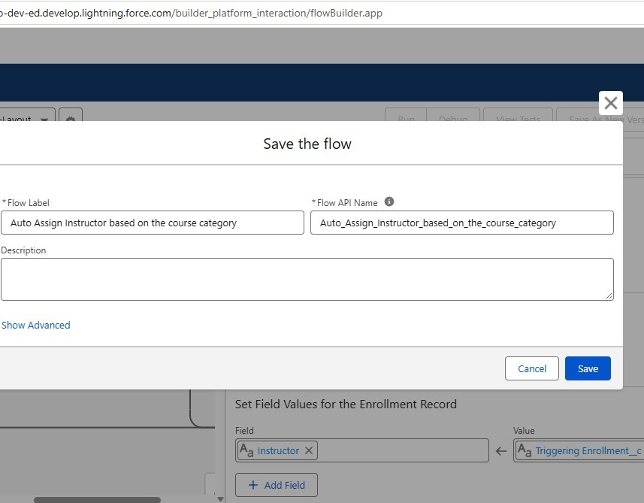

Activity 4: Auto-Create Task for Follow-Up

Purpose:
A follow-up task can be automatically generated when an enrollment request requires further action.

Steps:
1. Create a record-triggered flow for the Enrollment object.
2. Configure the trigger for the required enrollment status.
3. Check whether the status is Requested.
4. Identify the user responsible for follow-up.
5. Calculate a suitable task due date.
6. Create a Task record.
7. Set the task subject to Follow up on enrollment request.
8. Associate the task with the enrollment record.
9. Assign the task to the responsible user.
10. Save and activate the flow.

Milestone 11 – Reports:
Reports provide organized views of the information stored in Salesforce. They help users examine student, course, enrollment, and payment-related data.

Activity 1: Create “Students by Status” Report
1. Open Reports.
2. Select New Report.
3. Choose the Student report type.
4. Add the required student fields.
5. Group the records according to student status.
6. Review the displayed information.
7. Save the report as Students by Status.

Activity 2: Create “Enrollments by Course” Report
1. Create a new report.
2. Select the Enrollment report type.
3. Add the course information.
4. Group the records according to course.
5. Display the number of enrollments for each course.
6. Review the report.
7. Save it as Enrollments by Course.

Activity 3: Create “Pending Enrollment Approvals” Report
1. Create a new Enrollment report.
2. Add a filter for enrollment requests with Requested status.
3. Include student and course information.
4. Add owner and creation-date information where required.
5. Review the filtered records.
6. Save the report as Pending Enrollment Approvals.

Activity 4: Create “Revenue Report (Fees Paid)” Report
1. Create a new report using Enrollment records.
2. Filter the records to show enrollments where fees have been paid.
3. Group the information by course.
4. Add the applicable fee field.
5. Calculate the required total or summary.
6. Review the results.
7. Save the report as Revenue Report – Fees Paid.
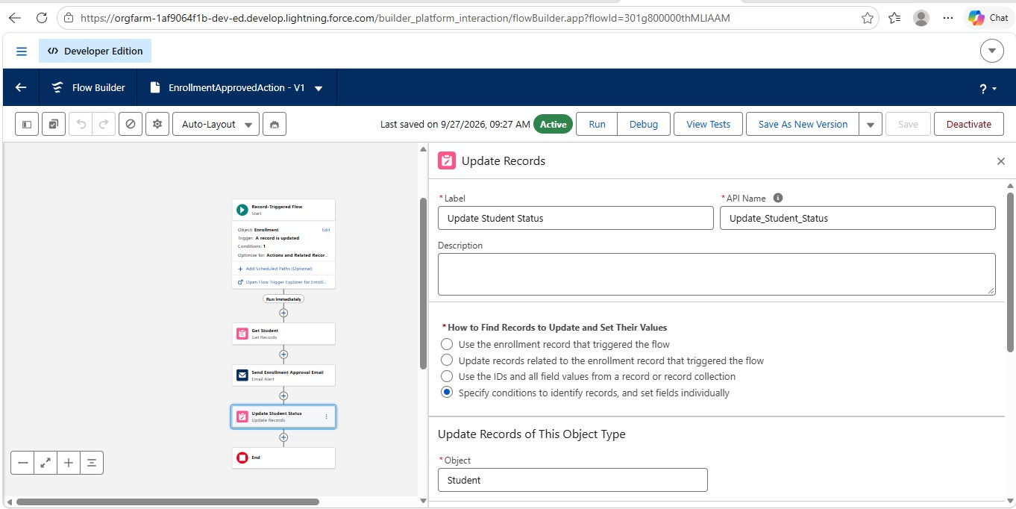
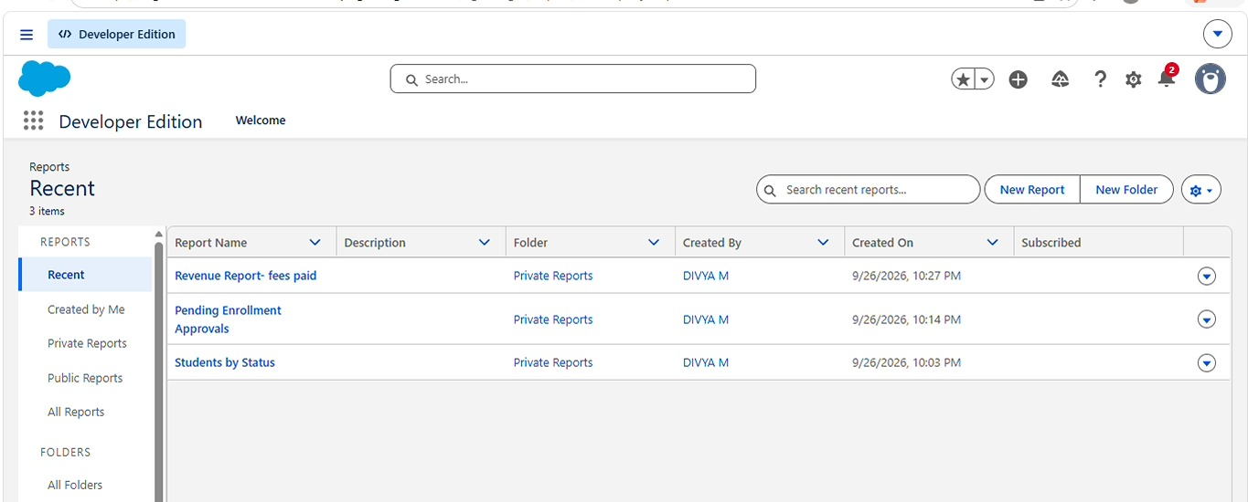

Milestone 12 – Dashboards:
Dashboards present important report information through visual components. They provide a quick overview of enrollment activities and help users interpret project data.

Activity 1: Create “Student Management Dashboard”

Steps:
1. Open Dashboards.
2. Select New Dashboard.
3. Enter the name Student Management Dashboard.
4. Select an appropriate folder.
5. Create the dashboard.
6. Add the required report components.
The dashboard can contain:
- Donut Chart → Students by Status
- Bar Chart → Enrollments by Course
- Gauge → Revenue Report – Fees Paid
- Table → Pending Enrollment Approvals
Arrange the components clearly on the dashboard. Review the visual information and select Save followed by Done.
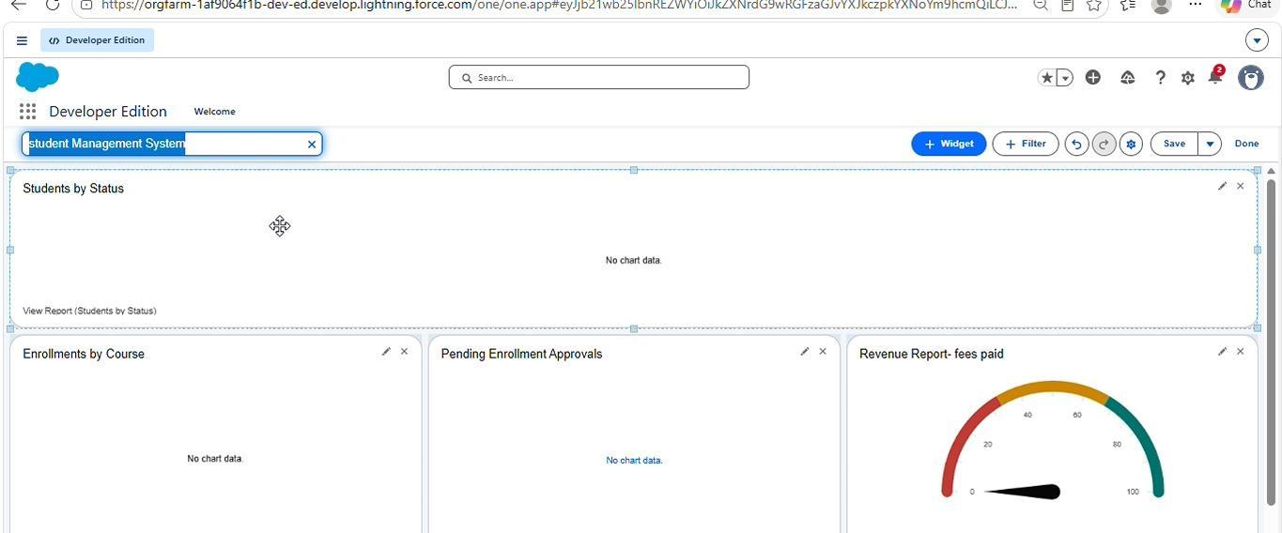
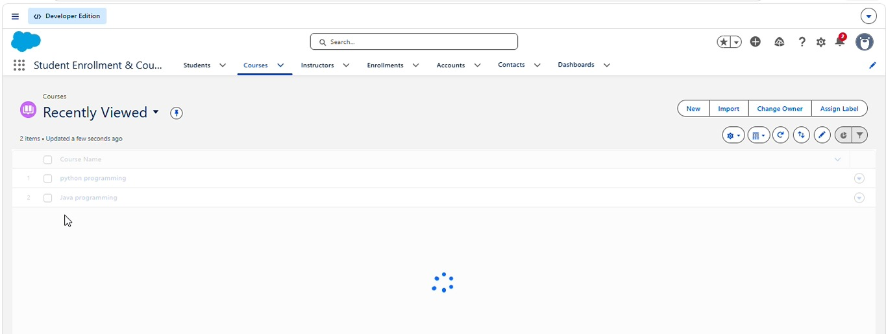
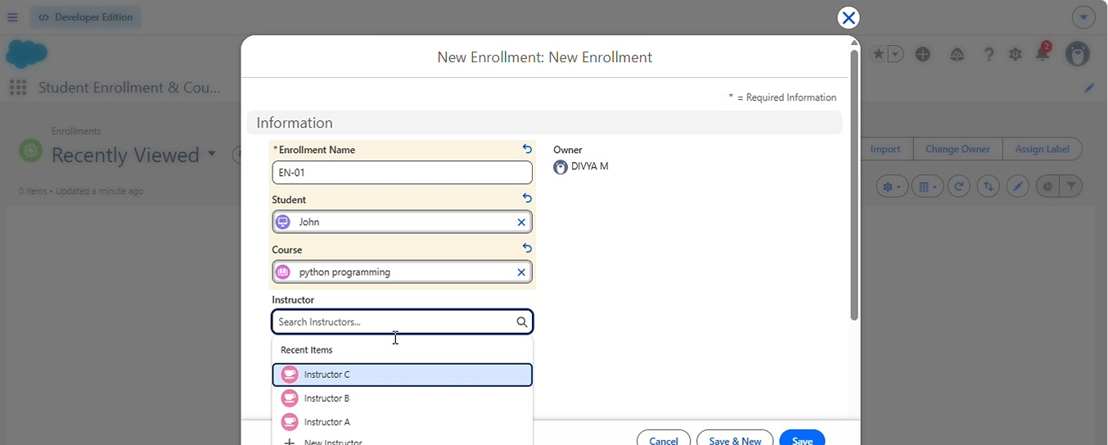

Milestone 13 – Security Setup
Security configuration controls how users access Salesforce records and application functions. Different users are provided with permissions according to their responsibilities.
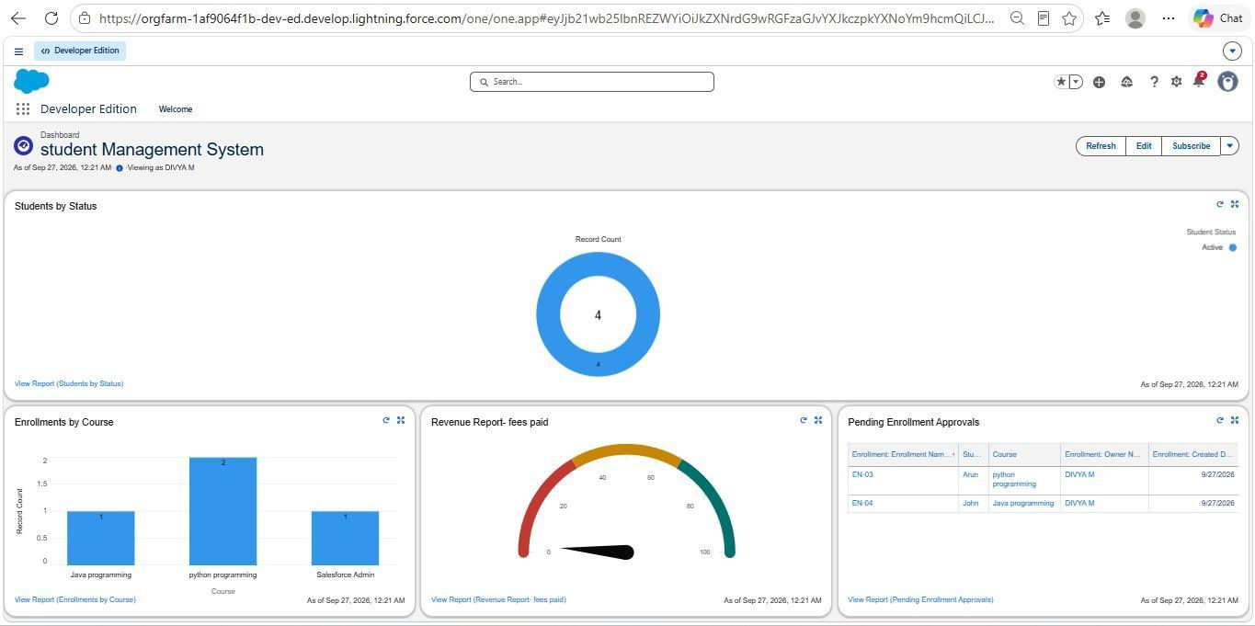

Activity 1: Configure Profiles
Profiles define the basic access available to different categories of users.

Required:
- Admin – Full access to the application.
- Enrollment Officer – Access required for creating and managing enrollment records.
- Instructor – Appropriate read access to assigned enrollment information.

Steps (example for Enrollment Officer):
1. Open Setup → Profiles.
2. Create or configure the Enrollment Officer profile.
3. Open the relevant object permissions.
4. Provide the required access to Enrollment.
5. Provide suitable access to Student and Course information.
6. Review the permissions.
7. Save the profile.
The Instructor profile can similarly be configured with restricted access appropriate to instructor responsibilities.

Activity 2: Create Permission Sets
Permission Sets provide additional permissions without changing the user's basic profile.
1. Open Setup → Permission Sets.
2. Create a new permission set.
3. Provide additional access to the required project objects.
4. Create a permission set for users who need additional report or dashboard privileges.
5. Configure the required permissions.
6. Assign the permission sets to the appropriate users.

Activity 3: Configure Sharing & OWD
Organization-Wide Defaults determine the basic record-level access available to users.

Steps:
1. Open Setup → Sharing Settings.
2. Review the Organization-Wide Default settings.
3. Configure access for Student, Course, and Enrollment records according to project requirements.
4. Keep sensitive enrollment information appropriately restricted.
5. Provide additional access through sharing mechanisms where necessary.
6. Save the security configuration.
For instructor-specific access, an appropriate user reference can be maintained on the Enrollment record. Sharing or automation mechanisms can then be used to provide the required records to the relevant instructor.

STUDENT MANAGEMENT SYSTEM OUTPUT
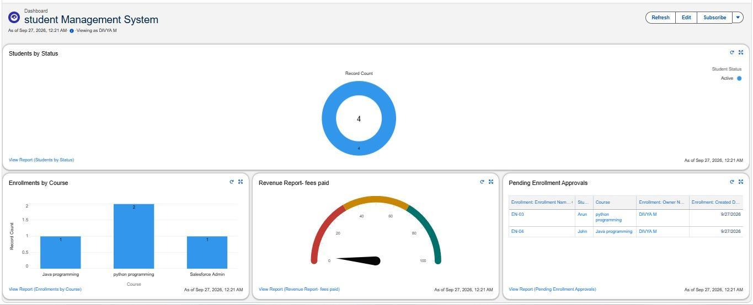

Milestone 14: Conclusion
The development phase completes the major configuration activities required for the Student Enrollment and Course Management System in Salesforce. The project establishes custom objects and fields for storing information, relationships for connecting records, validation rules for improving data accuracy, and approval processes for controlled enrollment processing.
Together, these components form a structured Salesforce-based solution for managing students, courses, instructors, and enrollment activities.

